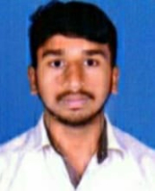

Profile
- Name : T.NARESH BABU
- Designation : LECTURER IN ELECTRONICS
- Date of Birth : 10-07-1999
- Educational Qualifications : M.Sc PHYSICS
- Teaching experience : 2 YEARS
- Research Experience : NIL
- Dissertation/Thesis Title : NIL
- No. of Research publications : NIL
- No. of Books Published : NIL
- No. of Major/Minor Research Projects: NIL
- Title of Minor Research Project : NIL
- No .of International Conferences Attended : NIL
- No. of National Conferences Attended : NIL
- No. of Papers Presented at the Seminars/Conferences: NIL
- Refresher Courses/Orientation Programs/Training Programs Attended: NIL
- Vidwaan Score : NIL
- Address : T. NARESH BABU , S/O T VENKATESWARARAO , MULAPARRU MADDIGUNTA CHERUVU . 534123

- E-mail Id : nareshthotharamudi@gmail.com
- Contact no : 8074665309

